Understanding network security concepts is essential, but seeing how these skills apply to real-world careers helps you chart your learning path. Let’s explore common roles and how the topics you’ve studied map to the skills they demand.
1. SOC Analyst (Security Operations Center Analyst)
Monitors networks and systems for security incidents, investigates alerts, and responds to threats.
Key Skills from This Course:
- Recognizing network threats (Sniffing, Spoofing, MITM, ARP Poisoning)
- Using tools like Wireshark and Nmap to analyze traffic
- Understanding firewalls, IDS/IPS, and network segmentation
SOC Analysts are the first line of defense. Your knowledge of layered security and monitoring helps detect breaches quickly.
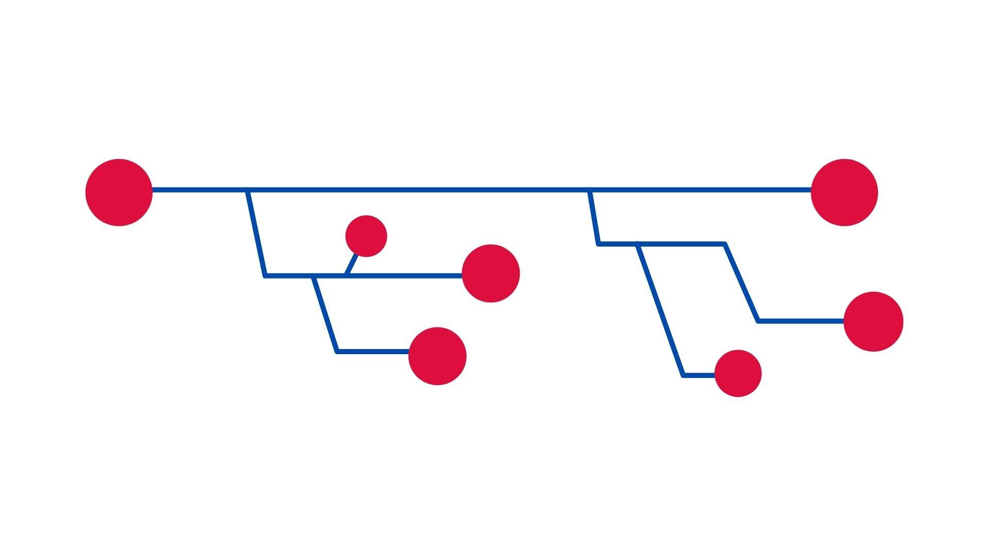
2. Network Security Engineer
Designs, implements, and maintains secure network infrastructure.
Key Skills from This Course:
- Configuring firewalls and VPNs (OpenVPN, pfSense)
- Implementing IPsec, VLANs, ACLs, and NAC
- Securing core devices like routers and switches
Engineers build the systems that protect organizations. Practical labs in this course give you a foundation to implement secure networks.
3. Penetration Tester (Ethical Hacker)
Simulates attacks on networks and applications to find vulnerabilities before attackers do.
Key Skills from This Course:
- Understanding protocols at every layer (TCP/IP, UDP, ICMP)
- Identifying weaknesses in LANs, Wi-Fi, and access controls
- Using tools like Nmap, Wireshark, and PGP for testing and communication security
Penetration testers help organizations identify flaws proactively. Knowledge of attacks and defenses allows you to think like a hacker, safely.

